From: http://www.zerohedge.com/news/2016-10-29/we-risk-being-collateral-damage-neocon-lust-war

"We Risk Being Collateral Damage In The Neocon Lust For War"

by Tyler Durden
Oct 29, 2016 10:00 PM
23
SHARES
Submitted by Chris Martenson via PeakProsperity.com,
The winds of change are now swirling so rapidly that it's hard to make sense of what’s happening. And adding to the confusion is an all-out effort by the establishment to convince the masses that, despite the multiplying signs of instability, "everything is fine".
The deceptions surrounding us are now constant and impossible to avoid. How much longer will it take until a critical mass of the populace starts to see through the delusion?
The stock and bond markets are rigged by central banks and their allies to go ever higher, enriching an elite few at the expense of everyone else. The mainstream media over-reports the inconsequential, and under-reports the most important things. It’s truly astonishing what is not being reported on, presumably in an effort to minimize attention on some really important matters (Yemen, Russia’s increasing concerns over western actions, Wikileaks on HRC, etc).
If it all weren’t so serious, it would be humorous because the chicanery is now so over-the-top obvious.
The elites often commit crimes without any consequences. It's so bad, we've seen the architects of wars based on lies get promoted to positions of greater power, now telling new lies on an even grander scale. (In DC, the polite term du jour is “fabrications”. But we’re all friends here, so let's use proper language: lies are lies.)
Meanwhile, whistleblowers end up facing the full weight of the law. And the little people face harsh, draconian consequences for even the most minor of infractions.
As James Howard Kunstler succinctly puts it: Racketeering is ruining us.
If you can make a lot of money doing it, in the US that’s A-OK with the powers that be. Who cares about the collateral damage, as long as Uncle Sam and his cronies get their cut?

The Winds Of Change
But this all is going to come crashing down, because it has to. Not because of a sudden case of enlightenment by the elites, but because of math.
Simple math, too.
While there are lots of sub-equations we could parse through, the parent of them all is this one: Endless exponential growth on a finite planet is impossible.
It’s really that simple. And what’s transpiring now is nothing more complicated than what happens when a culture’s main growth narrative no longer matches the limits of its reality.
Unfortunately, it’s possible to fool people for just long enough into thinking it’s a workable plan. Give something a couple of decades in the sun (cheap, plentiful petroleum, for example) and entire institutions, political and monetary systems and dogmas will be fashioned around it.
This kind of self-delusion is not new for humans. It's no different than if an ancient tribe was luckily blessed with 40 years of dependable rains which they attributed to a specific set of rituals. It’s not too long before correlation becomes confused with causation. And when the expected rains start ceasing to arrive, the rituals get more convoluted and increasingly desperate measures are called for to appease the angry gods.
Eventually, finally, people slowly wake up to the fact that their rituals and the weather never had anything to do with each other. But by then, society has usually torn itself apart, unable to align the contradictions.
This is what’s happening now. The narrative we live by is breaking down, and increasingly, our desperate ruling elites simply don’t know what to do. People are confused and so they want to either return to the past “Make America Great Again!”) or they want to cling to the present (“Stronger Together"…as in don’t rock the boat, preserve the status quo!).
Neither will work of course because the rains have ceased for reasons that have nothing to do with America's elaborate but quirky rituals (the current presidential race being a prime example of such).
And this is why, despite the fact that our true challenges are rooted in the mathematics of resource depletion, our undoing will come when the social fabric tears apart.
Which is why the current unrest escalating all over the globe is so important to track. As we watch less-resourced societies begin to fail in advance, we better understand the nature of the reckoning heading our way.
Among the many conflicts that are boiling over, the one that concerns me the most -- by far -- is the West's very intentional efforts to demonize Putin specifically, and Russia generally.
The tactics being used are no different from those used to disparage Saddam and his regime right before the invasion of Iraq. We’ve been down this path before; the playbook is literally exactly the same.
Blatantly obvious propaganda is being used, most heavily by the very same (and unrepentant) main stream media outlets that were used the last time around -- when we ended up commencing a 'pre-emptive' war based on ginned-up intelligence that turned out to be wholly false. We owe it to ourselves not be so easily led this time around.

The Winds Of War
The whole aim of practical politics is to keep the populace alarmed (and hence clamorous to be led to safety) by menacing it with an endless series of hobgoblins, all of them imaginary.
~ H. L. Mencken
Now, I'm sensitive to the idea put forth by some that this whole Putin demonization is merely the latest use of a hobgoblin intended to help get HRC elected president.
Obviously if this is true, it goes well beyond HRC herself. In the military industrial complex, there's a vast host of self-interested parties who feast on war and whose paychecks and future prospects depend heavily on it. There even are a few demented souls in the halls of power who believe in war as the best way to project one’s influence. Stew them together and you have a pretty good handle on what DC is all about these days.
So I'm sympathetic to the temptation to think: “Hey, it’s always a safe bet during an election year to try and appear tougher than your opponent…this is all just election year politicking and it will pass and fade after November 8th.”
Here’s why I don’t think that’s accurate. In fact, I think something deeper and more sinister has been set in motion.
The blackballing of Putin and Russia started years ago, in 2013, when Putin managed to convince then-president of Ukraine Yanukovych to back out of the agreement intended to bring Ukraine into the EU fold as the final NATO brick in the wall.
That set-back enraged the neocons in Washington DC mightily and they’ve been rapidly anti-Putin ever since. This neocon grudge has found help and support ever since from the UK, US, and EU press which were also willing partners in selling the fraudulent “evidence” that led to the Iraq war -- and Libya, too, and now Yemen and Syria.
As examples, these cartoonish magazine covers (both from 2014) look like they were designed by Intro to Psychology 101 students asked to create a propaganda hit piece:
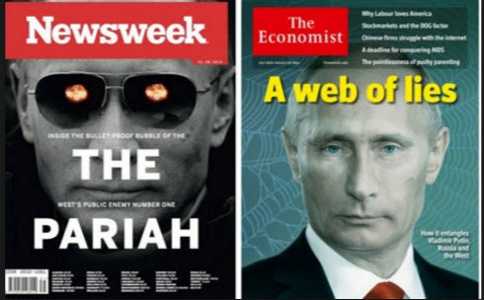
Heck, there's even potential evidence as far back as 2008: as exemplified by this TIME magazine cover where the "TIME" banner was placed behind Putin’s head in such a way that the peaks of the M gave him "horns". (For fun, see how many example of other leaders you can find where TIME did this -- there are precious few. The logo is almost always in front):
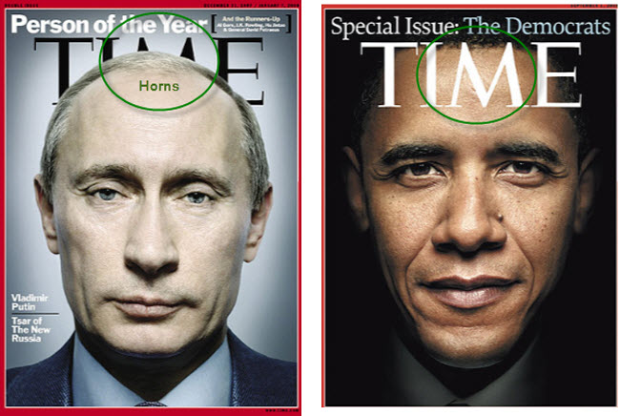
So the demonization began a long time ago, well before it’s reasonable to suspect HRCs advance team could start scheming about how to use an anti-Putin stance against Trump, or any other opponent.
But the media has continued to beat the Putin=bad drums, and with increasingly volume. Here are a few more recent examples:
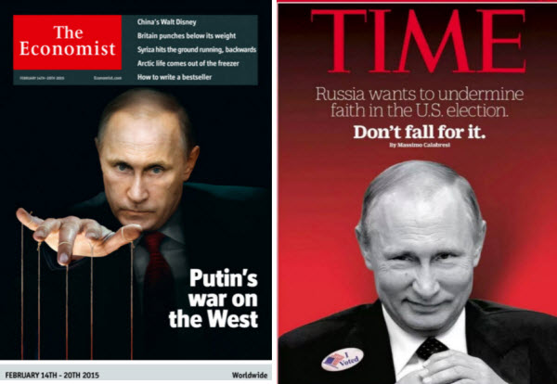
The message: Putin is manipulating us, and anybody who falls for it is a sucker. And if you dare to question the integrity of the US elections, which there is ample evidence that it is vulnerable to fraud & manipulation (listen to our podcast with election integrity analyst Brad Friedman), you are Putin’s patsy.
And here’s my favorite propaganda piece to date because it’s so blatantly over-the-top that it takes on a very special quality of being so bad it’s good. This is The Rocky Horror Picture Show of magazine cover art:
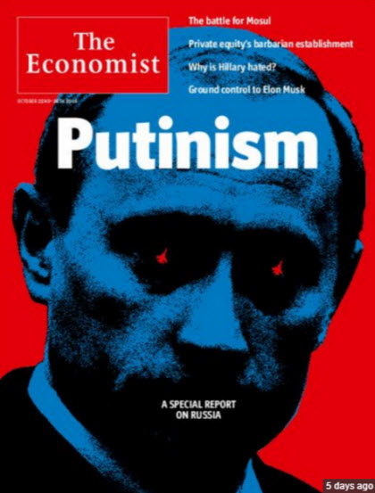
Okay, with all that said, we’ve established that “someone” has had it out for Putin for quite a long time. We might surmise who or what agencies that might be, but such speculation is best reserved for those with greater insights than I happen to have.
I just know propaganda when I see it. And I see it in the examples above, and in the media pervasively today. So where does this lead us?
Well, given the fact that Russia has just undertaken the largest nuclear readiness drill in its history involving its citizens, maybe we should think that Putin and Russia are no longer amused by all this antagonism and are taking it as something more sinister than simple politicking.
Or we should pay attention that Russia recently announced the arrival of its latest nuclear ICBM (nicknamed Satan-2) capable of delivering 15 warheads each.
And let’s not forget the even more recent announcement that a hypersonic glider warhead had been successfully tested, against which our military currently has no defense.
None of those Russian moves are being made in a vacuum of course. They've come only after many repeated provocations by the West, including assembling the largest gathering of military brigade forces on Russia’s borders since WW II. These are the kind of threats, mind you, that would have caused the US to go into an absolute snit long ago were the situation reversed.
The real question is: Why? What’s the plan here, if any exists? Who’s behind all this and why? If we can answer any of these, then perhaps we can assess the risks regular people like us and our loved ones may be facing as potential "collateral damage" of this warmongering.

The So-Called Elites
The “who” has emerged in this election, at least partially. We now have a few names to put to the program, and they're familiar ones.
This is, generally speaking, the same cast of characters that has been agitating for a more belligerent global stance prior to 9/11. Many of these names surfaced on my radar when the Project for a New American Century statement of principles was published in 1997. That document is pretty much all you need to read to understand the last 20 years of US foreign policy.
I mean, if you only had just one document to read on the topic, this one would pretty well sum it all up.
Well, here they all come again. This time right on the front page of the Washington Post, making renewed calls for an even more aggressive and bellicose US military posture. For anybody concerned about conflict with Russia, this is more terrifying than any haunted house you could possibly visit this Halloween:
Washington’s foreign policy elite breaks with Obama over Syrian bloodshed
Oct 20, 2016
by Greg Jaffe
There is one corner of Washington where Donald Trump’s scorched-earth presidential campaign is treated as a mere distraction and where bipartisanship reigns. In the rarefied world of the Washington foreign policy establishment, President Obama’s departure from the White House — and the possible return of a more conventional and hawkish Hillary Clinton — is being met with quiet relief.

The Republicans and Democrats who make up the foreign policy elite are laying the groundwork for a more assertive American foreign policy, via a flurry of reports shaped by officials who are likely to play senior roles in a potential Clinton White House.
It is not unusual for Washington’s establishment to launch major studies in the final months of an administration to correct the perceived mistakes of a president or influence his successor. But the bipartisan nature of the recent recommendations, coming at a time when the country has never been more polarized, reflects a remarkable consensus among the foreign policy elite.

This consensus is driven by a broad-based backlash against a president who has repeatedly stressed the dangers of overreach and the need for restraint, especially in the Middle East. “There’s a widespread perception that not being active enough or recognizing the limits of American power has costs,” said Philip Gordon, a senior foreign policy adviser to Obama until 2015. “So the normal swing is to be more interventionist.”

“The American-led international order that has been prevalent since World War II is now under threat,” said Martin Indyk, who oversees a team of top former officials from the administrations of Obama, George W. Bush and Bill Clinton assembled by the Brookings Institution. “The question is how to restore and renovate it.” The Brookings report — a year in the making — is due out in December.

Taken together, the studies and reports call for more-aggressive American action to constrain Iran, rein in the chaos in the Middle East and check Russia in Europe.

The studies, which reflect Clinton’s stated views, break most forcefully with Obama on Syria. Virtually all these efforts, including a report released Wednesday by the liberal Center for American Progress, call for stepped-up military action to deter President Bashar al-Assad’s regime and Russian forces in Syria.

“You can’t pretend you can go to war against Assad and not go to war against the Russians,” said a senior administration official who is involved in Middle East policy and was granted anonymity to discuss internal White House deliberations.
(Source)

There’s a lot to unpack in there. Let’s get started.
The article begins with the disquieting assertion that the presumptive return of a more hawkish Hillary Clinton to the white house is “being met with quiet relief.” You mean the longest stretch of active war in US history hasn't been enough for some of these folks?
I talk with a lot of people in the military who are sick and tired of America's endless wars and their endless rotations with no end in sight and no clear mission. Nobody can articulate what the US is doing in Afghanistan any more (and noting the enormous increase in heroin production is considered impolite).
Next, the article is loaded with “normalizing” words, such as ‘consensus,’ ‘broad-based’ and ‘bipartisan’ to make it seem that a more hawkish stance is really getting back to something we can all agree on. It’s centrist, bipartisan and broad-based after all.
It’s also insane when you combine it with the later part about how these folks want to undo the restraint of Obama and go after Syrian and Russian forces directly.
I’ve said it before and I’ll say it again: Getting into a shooting war with Russia would be a terrible idea. Insane really.
Not least of which is because, even if things don’t go nuclear (which they very well could given where we are in the shredding of the past narratives), then the US will discover that projecting its power all over the world is a heck of a lot harder when your navy is being sunk by the latest next-generation anti-ship missile technology.
Trust me, the petrodollar will get a lot weaker in a skinny minute as soon as American military power is revealed as stoppable.
I have a lot of faith in the training and equipment of the US military. But I also have faith in the power of a swarm of anti-ship hypersonic missiles to do a lot of damage.

The US Presidential Election
I'm on record as saying that I very much distrust the close relationship HRC has with the neocons and her hawkish foreign policy stance. Also, I do trust her readiness and willingness to get the US into more wars.
In the second presidential debate, she came right and said that she supports a no-fly zone over Syria. Quoting a US military general, I've since explained that doing so would meet the definition of an open act of war against Russia.
While there are a lot of issues on the table this election, I'm very much a single-issue voter when it comes to getting into a war with Russia. I want no part of it. I can't imagine any sane American would.
At best, it would be a wildly destructive waste of time, life and money. At worst it ends with an EMP (if we're lucky) or nuclear disaster (if we're not). Instead, we in the West should be confronting our massive overhang of debt, our looming energy predicament, and a host of ecological train wrecks right now -- not stuck in the fantasy that global warfare is somehow glorious or 'winnable'.
After the next war, there won’t be any bountiful period of economically-simulative rebuilding that some have wistfully longed for. That takes energy. And in case anybody missed it, the 'high net energy' conventional oil slipped into the rearview mirror almost ten years ago now. There won’t be any super-duper rebuilding after the next big war. Just a massive struggle to get us back to even.
So hey, let’s not do that. OK?
Back to the main point here. The HRC campaign has several very close ties with the neocons who were instrumental in selling the Iraq war. None quite as prominent as Michael Morell:
Clinton Adviser Proposes Attacking Iran to Aid the Saudis in Yemen
Oct 26, 2016

Michael Morell is a former acting director of the CIA and a national security adviser to Hillary Clinton — one who is widely expected to occupy a senior post in her administration.

He is also an opponent of the Iran nuclear agreement, a defender of waterboarding, and an advocate for making Russia “pay a price” in Syria by covertly killing Putin’s soldiers.

On Tuesday, Morell added another title to that résumé: proponent of going to war with Iran, for the sake of securing Saudi Arabia’s influence in Yemen.

“Ships leave Iran on a regular basis carrying arms to the Houthis in Yemen,” Morell said, in remarks to the Center for American Progress, the liberal think tank founded by Clinton campaign chairman John Podesta. “I would have no problem from a policy perspective of having the U.S. Navy boarding their ships, and if there are weapons on them, to turn those ships around.”

Morell did note, per Bloomberg’s Eli Lake, that this policy “raised questions of international maritime law.”

Which is a bit like saying, “Breaking into someone’s home, putting a gun in their face, and demanding they hand over all their weapons raises questions about armed-robbery law.”
(Source)
To me this is not an individual interested in a little Putin-bashing for the sake of votes. This is a guy who's deadly serious about using US power to get into a conflict not just with Russia, but with Iran as well.
Either of these adversaries could lead us into an armed confrontation that could escalate in ways we’d very seriously regret.
Even ‘just’ the shutting of the Strait of Hormuz would be a huge and mortal blow to a world economy saddled with low growth and enormous piles of debt. Iran could accomplish this easily using the mobile, land based missile launchers they currently have in stock.
Sink a couple of Very Large Crude Carriers (VLCCs) and it’s a whole new ball game for world trade.
In case you don’t take Mr. Morell all that seriously, I should remind you that he was the person who personally vetted and scrubbed the presentation that Colin Powell gave to the UN on Iraq’s weapons of mass destruction that led to the final war resolution.
Clearly telling a few, uh, "fabrications" is well within his talent center if/when needed to get the job done. He’s deadly serious about entering a conflict with Russia and Iran and he has Hillary’s ear. Hopefully other more moderate people do as well, but my concern still lies with the fact that some people will hear equal arguments but then make the decision based on how they lean.
Hillary leans hawkish. That’s just a matter of record at this point. As even liberal-leaning Chris Matthews of Hardball said recently, “People don’t change because we swear them into the White House.”
Nope. The best rule of relationships I have is: You'll be disappointed if you are expecting (requiring, or hoping for) them to be different tomorrow than they are today.

Conclusion
While I've focused on the election in this article, it may not even be relevant at all. That is, there may well be a machine running in the background that is larger than any potential candidate or President. It may well be that the careful preparation of propaganda groundwork against Putin that began in 2008 is part of a large plan the public is being intentionally kept in the dark about. Who knows?
But learning how Obama has frustrated the aspirations of the neocons vis-a-vis Syria and Russia tells me that the office of the president does matter, at least to a point.
I was personally horrified by what the US has brought to bear on Iraq, Libya, Syria and Afghanistan. All in the service of Deep State objectives that are anything but obvious.
My growing concern here is that the juggernaut that leads to war has already been untethered and is building up steam. I see it in the propaganda pieces against Russia on an almost daily basis. And I see Russia doing everything it can to both try and get the West to calm down and be reasonable, while getting its own citizens ready in case those efforts fail.
NATO is ramping up the pressure. Western media is faithfully (again) running necon talking points as if they were pearls of wisdom. We are heading back to the future.
Recently, for the very first time in my entire life, I have begun undertaking actual personal preparations for nuclear war.
I absolutely deplore that I feel this is necessary. But a core tenet we live by here at PeakProsperity.com is that when anxiety builds, you need to align your actions with your beliefs. Right now, my beliefs are loudly telling me that the risk of a serious conflict with Russia breaking out are no longer dismissable.
Similarly, I've committed to readers that when something concerns me enough to take action in my own personal life, I'll share it.
In Part 2: My Personal Preparations For Nuclear War, I share the steps I've taken this week as well as additional precautions folks concerned about this topic should consider.
Look, it's crazy were even talking about this. But as this article has shown, there's ample evidence that the pressure between the West and Russia is building. Given the outsized risks involved, making an investment in safety is only prudent. After all: nuclear way is one of those potential scenarios where its far better to be early or overenthusiastic in your precautions, than a day late.
Click here to read Part 2 of this report (free executive summary, enrollment required for full access)

